Customer Churn Analysis & Prediction

Summary
This project focuses on analysing customer churn in a telecommunications company using Power BI. The goal is to identify key factors influencing churn and provide actionable insights to improve customer retention. The project covers data cleaning, transformation, and dashboard development with business-focused insights.
Objectives
- Analyse customer churn behaviour
- Identify high-risk customers
- Understand impact of tenure, contract, and services
- Build interactive dashboards

Dataset Description
- Total Rows: 7043
- Total Columns: 21
Data Includes:
- Customer demographics
- Service usage
- Billing information
- Contract details
- Churn status

Tools & Technologies
- Power BI
- Power Query
- DAX

Task 1: Data Connection
Description
The dataset was imported into Power BI for analysis.
Steps:
- Loaded dataset using Get Data
- Verified column names and structure
- Checked preview for data consistency

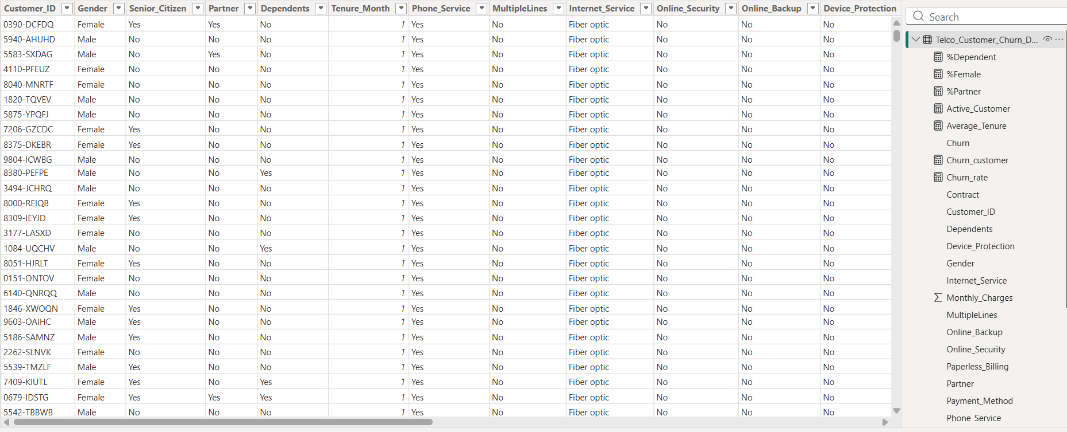

Task 2: Data Cleaning & Transformation
Description
Raw data was cleaned and transformed to improve quality.
Steps:
- Removed null and duplicate values
- Changed data types
- Standardized categorical values
- Converted:
  - 0 → No, 1 → Yes (Senior Citizen)
- Created Tenure Group column:
  - 0–12 → New
  - 13–36 → Mid-term
  - 37+ → Long-term

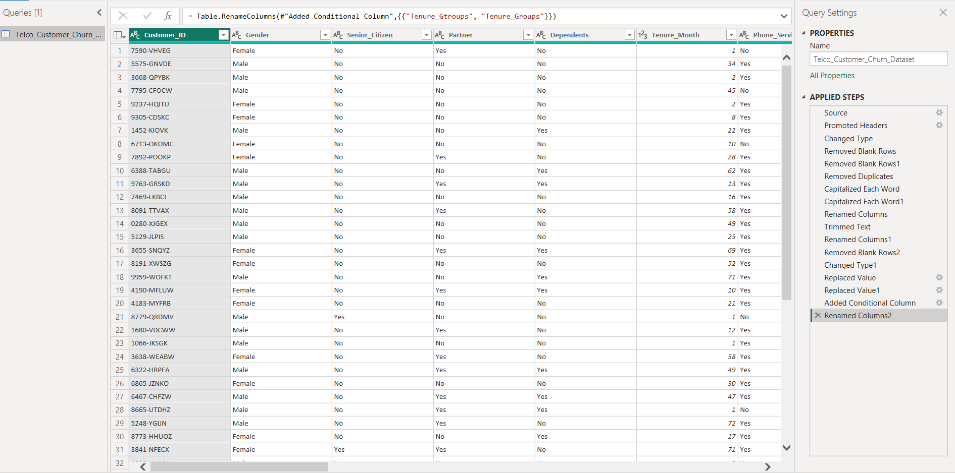

Task 3: Dashboard Component
A. Churn Rate Overview
Visuals:
- KPI Cards
- Donut Chart
Insights:
- Churn rate is ~27%
- Electronics Check customer churn more
- Active customers represent the number of customers currently using the service.
- A higher number of active customers indicates better retention and customer satisfaction
- Customers with Month-to-Month contracts show the highest churn rate compared to One-Year or Two-Year contracts.

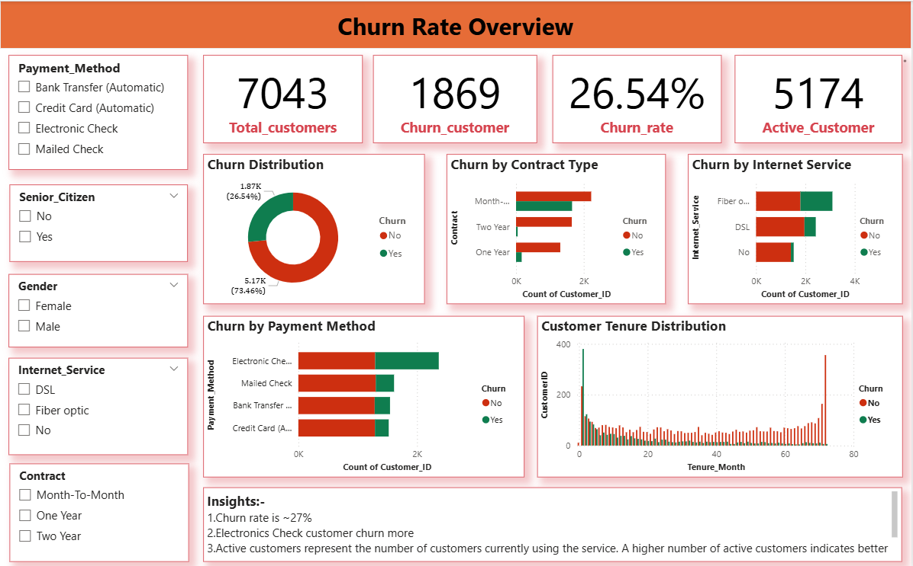

B. Customer Demographics
Visuals:
- Bar charts (Gender, Partner, Dependents)
Insights:
- Customer distribution is balanced across gender
- Customers without partners show higher churn
- Customers without dependents are more likely to churn
- Gender has minimal impact on churn behavior
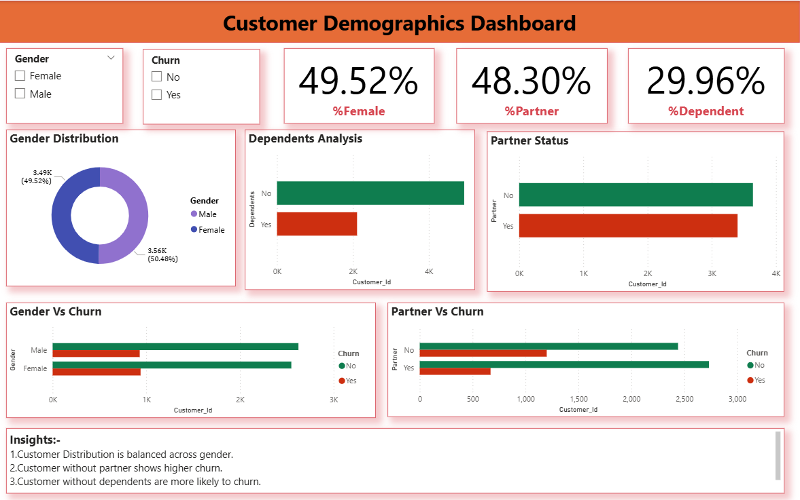

C. Customer Tenure Analysis
Visuals:
- Histogram
- Line Chart
- Bar Chart (Tenure Group)
- Box Plot
Insights:
- Customers with low tenure (0–12 months) show the highest churn
- Customers with long tenure are more stable and loyal
- Most churn happens during the early stage of customer lifecycle
- Retention improves significantly after long-term engagement

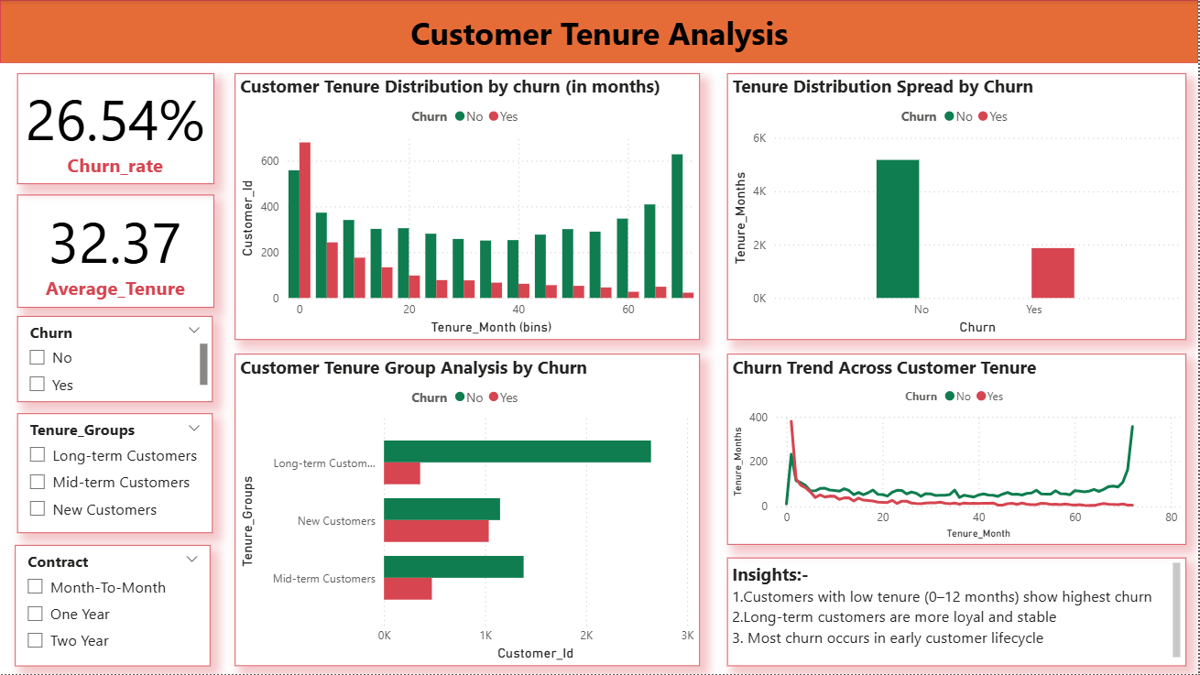

D. Churn Analysis
Visuals:
- Bar Chart (Contract)
- Bar Chart (Payment Method)
- Bar Chart (Internet Service)
Insights:
- Customers with Month-to-Month contracts show the highest churn, indicating lack of long-term commitment
- Electronic Check users have higher churn, possibly due to payment experience issues
- Customers using Fiber Optic services show increased churn, suggesting service cost or quality concerns
- Long-term contracts significantly improve customer retention
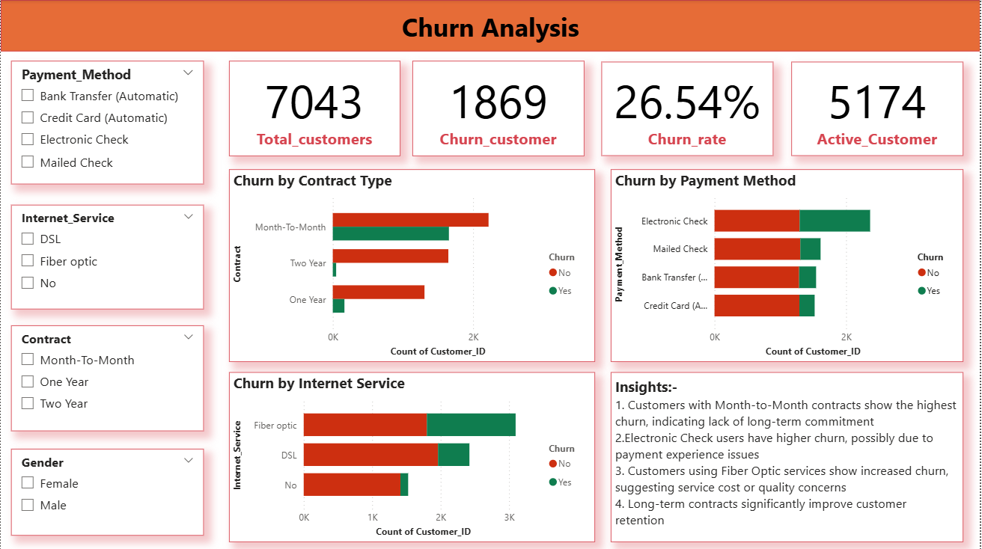

Final Dashboard
Objective:
- Combine all the task:
- Churn Overview
- Demographics
- Tenure Analysis
- Churn Analysis
Visuals:
- Add KPI Cards
- Add Slicers
- Donut Chart
- Bar Chart
- Line Chart
- Histograms
Key Insights
- Overall churn rate is around 26–27%
- Month-to-Month contracts have the highest churn
- Electronic Check users churn more frequently
- Fiber Optic customers show higher churn
- Maximum churn occurs in early tenure (0–12 months)
- Long-term customers show strong loyalty
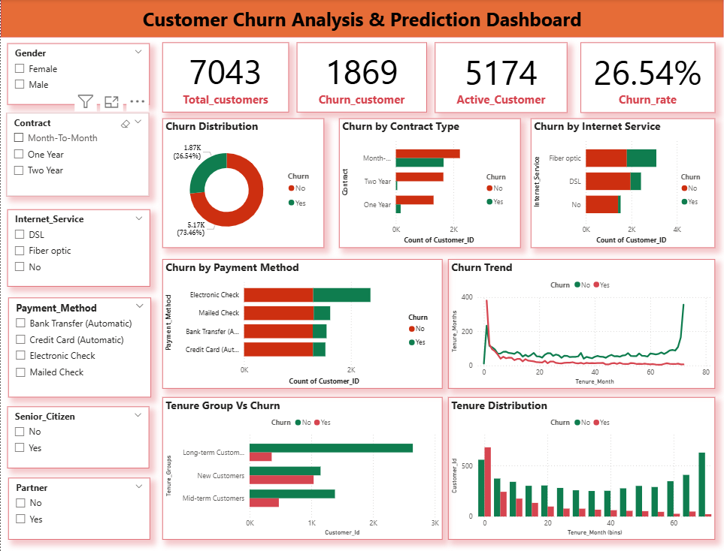

Business Recommendations
- Improve onboarding experience
- Promote long-term contracts
- Improve payment experience
- Focus on early customer engagement

Conclusion
The project successfully identifies key churn drivers and provides actionable insights to improve customer retention strategies.

